# Exercises: Table Relations

This document defines the **exercise assignments** for the ["Databases Basics - MSSQL" course @ Software University.](https://softuni.bg/trainings/3491/ms-sql-september-2021)

## One-To-One Relationship

Create **two** tables and use appropriate data types.

### Example:

|  |  |  |  |  |  |  |
| --- | --- | --- | --- | --- | --- | --- |
| **Persons** | | | |  | **Passports** | |
| **PersonID** | **FirstName** | **Salary** | **PassportID** |  | **PassportID** | **PassportNumber** |
| 1 | Roberto | 43300.00 | 102 |  | 101 | N34FG21B |
| 2 | Tom | 56100.00 | 103 |  | 102 | K65LO4R7 |
| 3 | Yana | 60200.00 | 101 |  | 103 | ZE657QP2 |

**Insert**the data from the example above. Alter the **customers'** table and make **PersonID**a **primary key**. Create a **foreign key** between **Persons** and **Passports**by using **the PassportID** column.

CREATE DATABASE [EntityRelationsDemo]

USE [EntityRelationsDemo]

CREATE TABLE [Passports] (

[PassportID] INT PRIMARY KEY NOT NULL,

[PassportNumber] CHAR(8) NOT NULL

)

CREATE TABLE [Persons](

[PersonID] INT PRIMARY KEY IDENTITY NOT NULL,

[FirstName] VARCHAR(50) NOT NULL,

[Salary] DECIMAL(9, 2) NOT NULL,

[PassportID] INT FOREIGN KEY REFERENCES [Passports]([PassportID]) UNIQUE NOT NULL

)

INSERT INTO [Passports]([PassportID], [PassportNumber])

VALUES

(101, 'N34FG21B'),

(102, 'K65LO4R7'),

(103, 'ZE657QP2')

INSERT INTO [Persons]([FirstName], [Salary], [PassportID])

VALUES

('Roberto', 43300.00, 102),

('Tom', 56100.00, 103),

('Yana', 60200.00, 101)

## One-To-Many Relationship

Create **two** tables and use appropriate data types.

### Example:

|  |  |  |  |  |  |  |
| --- | --- | --- | --- | --- | --- | --- |
| **Models** | | |  | **Manufacturers** | | |
| **ModelID** | **Name** | **ManufacturerID** |  | **ManufacturerID** | **Name** | **EstablishedOn** |
| 101 | X1 | 1 |  | 1 | BMW | 07/03/1916 |
| 102 | i6 | 1 |  | 2 | Tesla | 01/01/2003 |
| 103 | Model S | 2 |  | 3 | Lada | 01/05/1966 |
| 104 | Model X | 2 |  |  | | |
| 105 | Model 3 | 2 |  |  | | |
| 106 | Nova | 3 |  |  | | |

**Insert** the data from the example above and add **primary keys** and **foreign keys**.

CREATE TABLE [Manufacturers](

[ManufacturerID] INT PRIMARY KEY IDENTITY NOT NULL,

[Name] VARCHAR(50) NOT NULL,

[EstablishedOn] DATE NOT NULL

)

CREATE TABLE [Models](

[ModelID] INT PRIMARY KEY IDENTITY(101, 1) NOT NULL,

[Name] VARCHAR(50) NOT NULL,

[ManufacturerID] INT FOREIGN KEY REFERENCES [Manufacturers]([ManufacturerID]) NOT NULL

)

INSERT INTO [Manufacturers]([Name], [EstablishedOn])

VALUES

('BMW', '03/07/1916'),

('Tesla', '01/01/2003'),

('Lada', '01/05/1966')

INSERT INTO [Models]([Name], [ManufacturerID])

VALUES

('X1', 1),

('i6', 1),

('Model S', 2),

('Model X', 2),

('Model 3', 2),

('Nova', 3)

SELECT * FROM [Models]

## Many-To-Many Relationship

Create **three** tables and use appropriate data types.

### Example:

|  |  |  |  |  |  |  |  |
| --- | --- | --- | --- | --- | --- | --- | --- |
| **Students** | |  | **Exams** | |  | **StudentsExams** | |
| **StudentID** | **Name** | **ExamID** | **Name** | **StudentID** | **ExamID** |
| 1 | Mila | 101 | SpringMVC | 1 | 101 |
| 2 | Toni | 102 | Neo4j | 1 | 102 |
| 3 | Ron | 103 | Oracle 11g | 2 | 101 |
|  | |  | | 3 | 103 |
| 2 | 102 |
| 2 | 103 |

Insert the data from the example above and add **primary keys** and **foreign keys**. Keep in mind that the table "**StudentsExams"** should have a **composite primary key**.

CREATE TABLE [Students](

[StudentID] INT PRIMARY KEY IDENTITY NOT NULL,

[Name] VARCHAR(50) NOT NULL

)

CREATE TABLE [Exams](

[ExamID] INT PRIMARY KEY IDENTITY(101, 1) NOT NULL,

[Name] NVARCHAR(75) NOT NULL

)

CREATE TABLE [StudentsExams](

[StudentID] INT FOREIGN KEY REFERENCES [Students]([StudentID]) NOT NULL,

[ExamID] INT FOREIGN KEY REFERENCES [Exams]([ExamID]) NOT NULL,

PRIMARY KEY ([StudentID], [ExamID])

)

INSERT INTO [Students]([Name])

VALUES

('Mila'),

('Toni'),

('Ron')

INSERT INTO [Exams]([Name])

VALUES

('SpringMVC'),

('Neo4j'),

('Oracle 11g')

INSERT INTO [StudentsExams]([StudentID], [ExamID])

VALUES

(1, 101),

(1, 102),

(2, 101),

(3, 103),

(2, 102),

(2, 103)

SELECT * FROM [Students]

SELECT * FROM [Exams]

SELECT * FROM [StudentsExams]

## Self-Referencing

Create **one** table and use appropriate data types.

### Example:

|  |  |  |
| --- | --- | --- |
| **Teachers** | | |
| **TeacherID** | **Name** | **ManagerID** |
| 101 | John | NULL |
| 102 | Maya | 106 |
| 103 | Silvia | 106 |
| 104 | Ted | 105 |
| 105 | Mark | 101 |
| 106 | Greta | 101 |

Insert the data from the example above and add **primary keys** and **foreign keys**. The **foreign key** should be between **ManagerId** and **TeacherId**.

CREATE TABLE [Teachers](

[TeacherID] INT PRIMARY KEY IDENTITY (101, 1) NOT NULL,

[Name] VARCHAR(50) NOT NULL,

[ManagerID] INT FOREIGN KEY REFERENCES [Teachers]([TeacherID])

)

INSERT INTO [Teachers]([Name], [ManagerID])

VALUES

('John', NULL),

('Maya', 106),

('Silvia', 106),

('Ted', 105),

('Mark', 101),

('Greta', 101)

## Online Store Database

Create a new database and design the following structure:

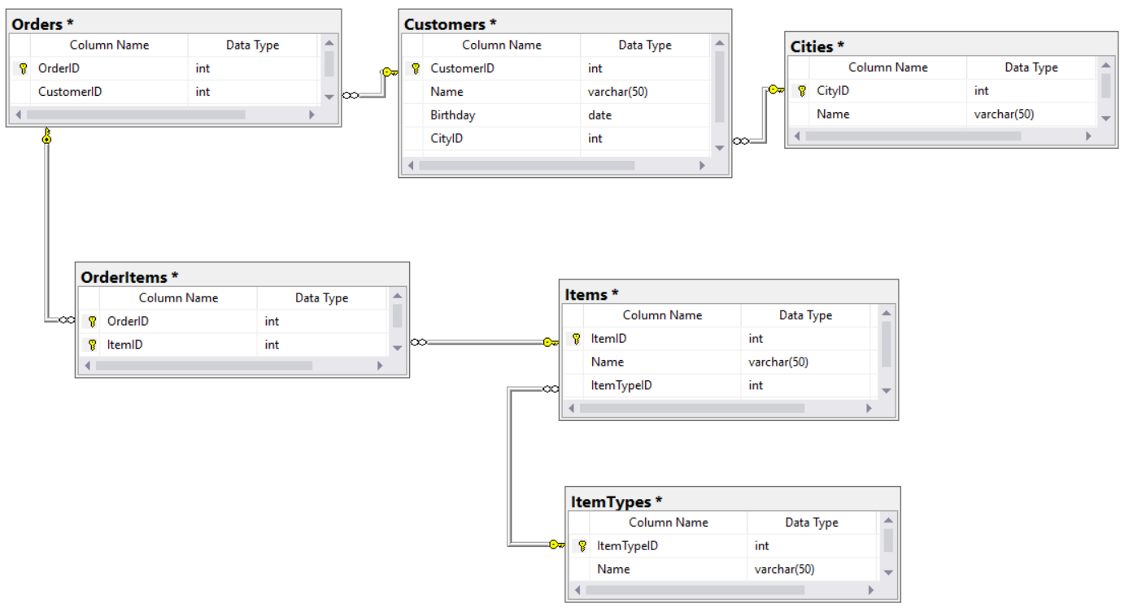

## University Database

Create a new database and design the following structure:

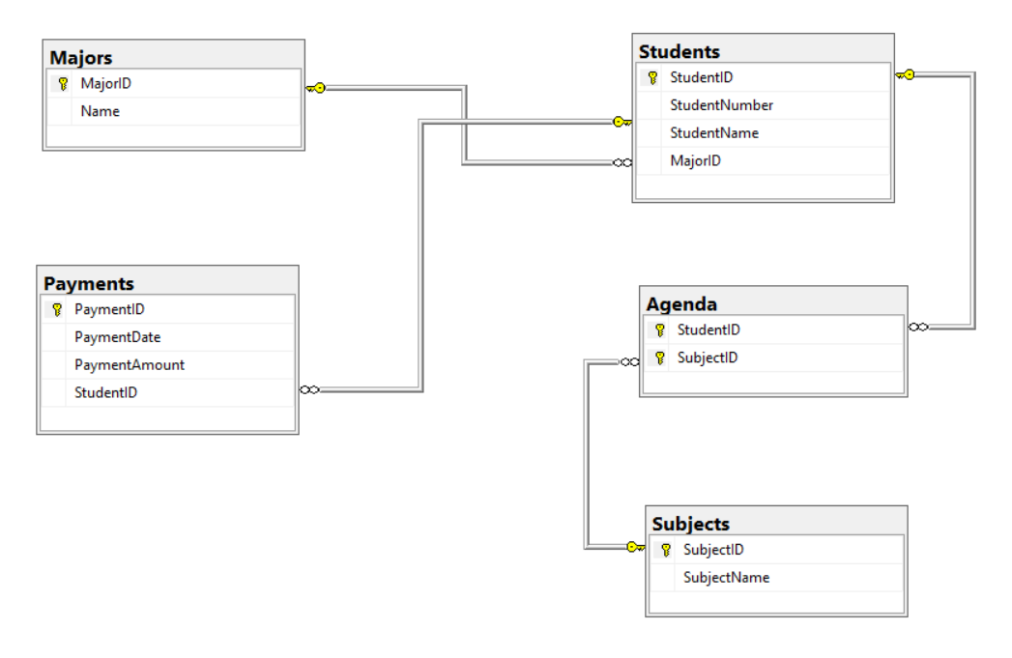

## SoftUni Design

Create an **E/R Diagram** of the SoftUni Database. There are some **special relations** you should **check out**:

* Employees are **self-referenced** (ManagerID)
* Departments have **One-to-One** with the Employees (ManagerID)
* Employees have **One-to-Many** (DepartmentID)

You might find it interesting how it looks on the diagram.

## Geography Design

Create an **E/R Diagram** of the Geography Database.

## *Peaks in Rila

Display **all peaks** for **"Rila"** mountain. Include:

* **MountainRange**
* **PeakName**
* **Elevation**

Peaks should be **sorted** by **elevation descending**.

### Example

|  |  |  |
| --- | --- | --- |
| **MountainRange** | **PeakName** | **Elevation** |
| Rila | Musala | 2925 |
| … | … | … |